TASK-1
CODE:
INCLUDE Irvine32.inc
.data
snum byte -100
unum byte 200
holder byte ?
exit
main ENDP
END main

TASK-2
INCLUDE Irvine32.inc
.data
num1 DWord 500
num2 DWord 200
.code
main PROC
mov eax, 0
mov eax,num1
mov ebx,num2
add eax,ebx
call writeInt
exit
main ENDP
END main
Screenshot:
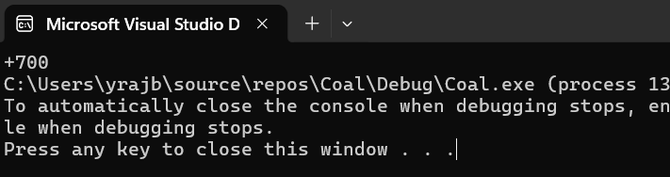

TASK-3
Using call dumpregs because we cannot access ebx directly with call writeint
INCLUDE Irvine32.inc
.code
main PROC
mov ebx,0
mov ebx,90
call dumpregs
call crlf
mov ebx,5Ah
call dumpregs
call crlf
mov ebx,01011010b
call dumpregs
call crlf
mov ebx,'Z'
call dumpregs
call crlf
exit
main ENDP
END main
Screenshot:
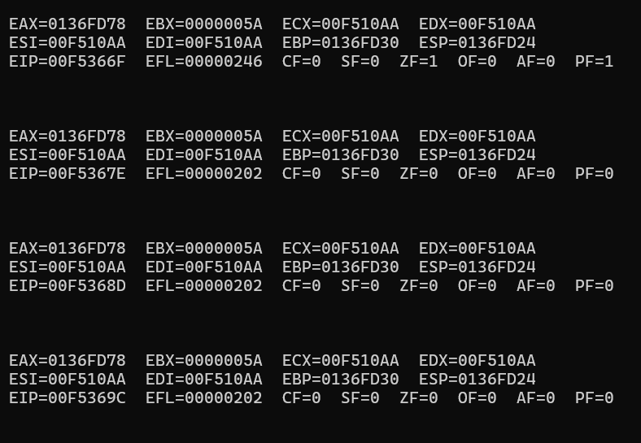

TASK-4
INCLUDE Irvine32.inc
.code
main PROC
mov eax,0
mov eax ,30000h
add eax,60000h
sub eax,10000h
call writehex
call crlf
call writeint
exit
main ENDP
END main
Screenshot:
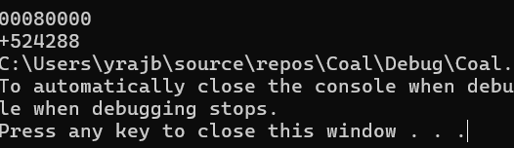

TASK-5
INCLUDE Irvine32.inc
.data
marks Byte 8 dup(5)
words Word 5 dup(?)
exit
main ENDP
END main

